# File permissions in Linux

## Project description

In this project I checked the file privileges in the projects directory to ensure least privilege principle was enforced. This included any hidden files within the directory and also other directories themselves.

## Check file and directory details

I started by navigating to the projects file. (cd /home/analyst/projects)

I then listed all of the files within the directory. (ls -la)

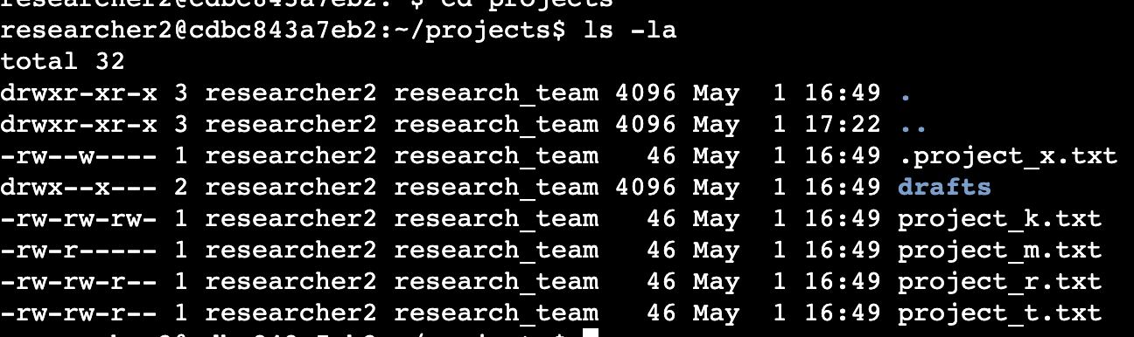

## Describe the permissions string

The permissions string is made up of 10 characters. The first character is either a ‘-’ if we are looking at a file or ‘d’ if we are looking at a directory. The next 3 characters involve the permissions for the user/owner group of the file/directory. ‘-’ indicates no permission in an area. In order it is read, write and execute or rwx. If the user has read and write privileges but not execute then it would display rw-. The next 3 characters follow the same principle, however, they refer to a group of users. For example, the security team. The final 3 characters refer to the user group other. The final piece of the output is a timestamp of when the file has been last modified, the user name, group name etc



## Change file permissions

To change the file permissions of a particular file I use the command chmod. I then indicate the user group in which i want to change a permission for ie ‘u’ for user, a ‘+’ or ‘-’ operator to indicate if I am adding or taking a privilege away and finally the permission(s) I am adding or taking away ie. x

In knowing this i changed the permissions to the drafts directory as nobody should be able to write to or execute this directory. I took away privileges for both the user and group.

‘Chmod u-wx,g-w drafts’



Before command:



After command:



## Change file permissions on a hidden file

To change file permissions on a hidden file you first need to locate the hidden file. You can locate it and check its permissions at the same time by using the command ls -la. Hidden files will be prefixed with a period. When you find the file that needs to be changed you can follow the same steps as mentioned above using the chmod command.

Hidden file before command:



Command:



Hidden file after command:



## Change directory permissions

When using the ls-la command, directories are prefixed with the letter ‘d’ before the permissions as opposed to ‘-’ to indicate something is a file. To change the permissions you follow the exact same steps using the chmod command and suffixing your arguments with the name of the directory that you need to update the permissions for.

## Summary

In this small project I learned some key concepts in the world of cybersecurity. I learned to be able to use Linux to navigate through different directories and modify privileges in files, hidden files and other directories. Access management is vital in keeping sensitive data safe from malicious actors so in this case, enforcing the least privilege principle helped me improve the security posture of my files.